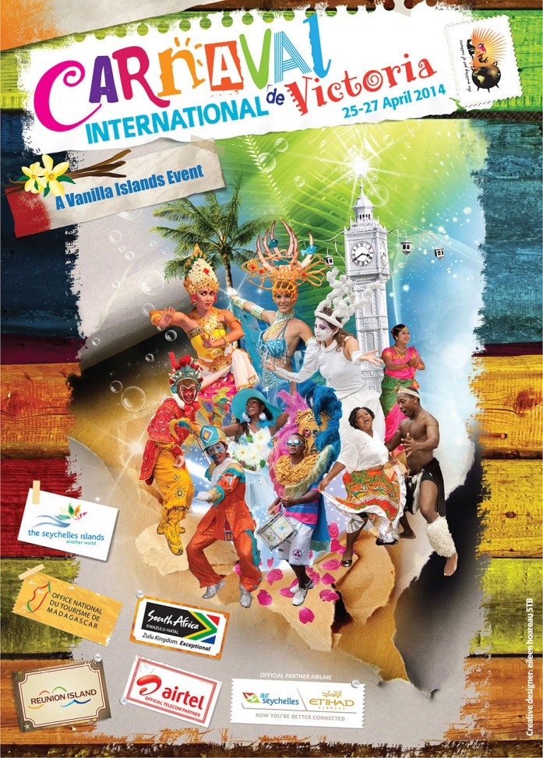
Highlights of the three day event will include:
Day 1 – The official opening of the carnival
- Live music
- Live entertainment shows
- An array of international food stalls.
Day 2 – Carnival procession day
- A spectacular carnival procession including local and international floats celebrating the theme of ‘a melting pot of cultures’.
Day 3 – Family fun day
- A day of festivities for all the family lasting into the night
- Food stalls
- Live bands (local and international).
For further information please visit: www.seychelles.travel

Seychelles International Carnival of Victoria 2014 (25 - 27 April 2014)
Ever since Seychelles first settlement, it has always been a melting pot of people from all the corners of the world.
This year, Seychelles International Carnival of Victoria is set to be the most spectacular yet.
Revelers from around the world will be welcomed with lights and banners throughout Victoria.
Seychelles is also inviting the world’s most prestigious carnivals representatives to participate in three days of celebration along with cultural groups from the community of nations.
Seychelles will come under the international and local spotlight at International Carnival of Victoria. It will feature a procession of colorful floats representing the various participants’ national carnivals, as well as a raft of other dedicated activities all of which will fall under the carnival’s theme.
If You're craving for wilderness, excitement and entertainments, head to the Seychelles International Carnival of Victoria this April.

